**Experiment 6**

Student Name: Aditi R Sinha UID: 22BCS15130

**Branch: BE-CSE Section/Group: KRG2B**

**Semester: 6th Date of Performance: 04/03/2025**

**Subject Name: Project Based Learning with JAVA Subject Code: 22CSH-359**

1. **Aim:**

**Easy Level:** Write a program to sort a list of Employee objects (name, age, salary) using lambda expressions.

1. **Implementation/Code:**

import java.util.*;

import java.util.stream.Collectors;

class Employee {

String name;

int age; double salary;

public Employee(String name, int age, double salary) {

this.name = name; this.age = age; this.salary = salary;

}

public String toString() { return "Name: " + name + ", Age: " + age + ", Salary: " + salary;

}

}

public class EmployeeSort { public

static void main(String[] args) {

List<Employee> employees = new ArrayList<>(); employees.add(new Employee("John", 30, 50000)); employees.add(new Employee("Alice", 25, 60000)); employees.add(new Employee("Bob", 35, 45000));

System.out.println("Sorted by Name:");

# COMPUTER SCIENCE & ENGINEERING

List<Employee> sortedByName = employees.stream()

.sorted((e1, e2) -> e1.name.compareTo(e2.name))

.collect(Collectors.toList()); sortedByName.forEach(System.out::println);

System.out.println("\nSorted by Age:");

List<Employee> sortedByAge = employees.stream()

.sorted((e1, e2) -> Integer.compare(e1.age, e2.age))

.collect(Collectors.toList()); sortedByAge.forEach(System.out::println);

System.out.println("\nSorted by Salary:");

List<Employee> sortedBySalary = employees.stream()

.sorted((e1, e2) -> Double.compare(e1.salary, e2.salary))

.collect(Collectors.toList()); sortedBySalary.forEach(System.out::println);

}

}

**OUTPUT :**

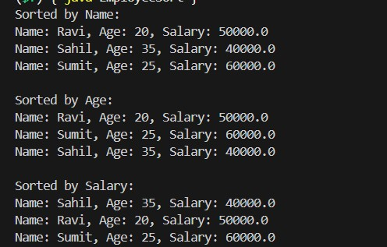

1. **Aim**: Create a program to use lambda expressions and stream operations to filter students scoring above 75%, sort them by marks, and display their names.
2. **Implementation/Code**: import java.util.*;

import java.util.stream.Collectors;

class Student {

String name; double percentage;

public Student(String name, double percentage) { this.name = name;

this.percentage = percentage; }

public String toString() { return "Name: " + name + ", Percentage: " + percentage;

}

}

public class StudentFilterSort { public static void main(String[] args) { List<Student> students = new ArrayList<>(); students.add(new Student("Shreya", 92.5)); students.add(new Student("Aditi", 85.0)); students.add(new Student("Ansh", 90.0)); students.add(new Student("Raju", 78.5)); System.out.println("Students scoring above 75%, sorted by marks:");

students.stream()

.filter(student -> student.percentage > 75)

.sorted((s1, s2) -> Double.compare(s2.percentage, s1.percentage))

.map(student -> student.name)

.forEach(System.out::println); }

}

# COMPUTER SCIENCE & ENGINEERING

**OUTPUT:**

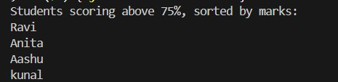

1. **Aim:** Write a Java program to process a large dataset of products using streams. Perform operations such as grouping products by category, finding the most expensive product in each category, and calculating the average price of all products.
2. **Implementation/code:**

import java.util.*; import java.util.stream.Collectors; class Product {

String name; String category; double price;

public Product(String name, String category, double price) {

this.name = name; this.category = category; this.price = price;

}

public String toString() { return "Name: " + name + ", Category: " + category + ", Price: " + price;

}

}

public class ProductProcessor { public static void

main(String[] args) { List<Product> products = new

ArrayList<>(); products.add(new Product("Laptop",

"Electronics", 999.99)); products.add(new Product("Phone",

"Electronics", 599.99)); products.add(new Product("Shirt",

"Clothing", 29.99)); products.add(new Product("Jacket",

"Clothing", 89.99)); products.add(new Product("Book",

"Stationery", 15.99)); products.add(new Product("Pen",

"Stationery", 2.99));

System.out.println("Products grouped by category:");

Map<String, List<Product>> byCategory = products.stream()

.collect(Collectors.groupingBy(product -> product.category));

byCategory.forEach((category, productList) -> {

System.out.println(category + ":");

productList.forEach(System.out::println);

});

System.out.println("\nMost expensive product in each category:"); Map<String,

Optional<Product>> mostExpensive = products.stream() .collect(Collectors.groupingBy(

product -> product.category,

Collectors.maxBy((p1, p2) -> Double.compare(p1.price, p2.price))

));

mostExpensive.forEach((category, product) ->

System.out.println(category + ": " + product.get()));

double averagePrice = products.stream()

.mapToDouble(product -> product.price)

.average()

.orElse(0.0);

System.out.println("\nAverage price of all products: $" + String.format("%.2f", averagePrice));

}

}

**Output:**

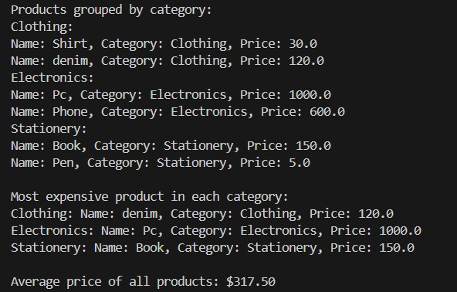

**3. Learning Outcome:**

* Understand how to sort by different data types (String, int, double) using lambda expressions
* Gain knowledge of the sorted() method in streams
* Understand how to handle more complex data processing tasks with streams
* Understand how to replace traditional loops with stream-based operations.
* Using how lambda expression works in java.